Class Maintenance

- To view a Class List (Pages 1-2)
- To add a student, to a Class List (Pages 3-4)
- To add students from a Tag List (Pages 5-6)
- To remove a student, from a Class List (Pages 7-8)
- To add a Staff member, to a Class (Page 9)

To view a Class List:
With Synergetic open,
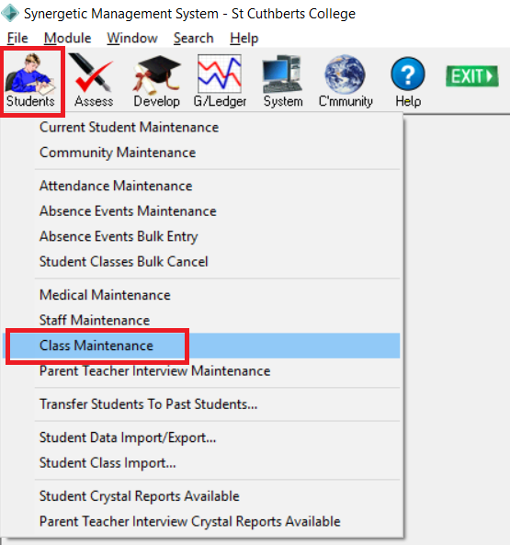
- Go to Students > Class Maintenance

- Select the File Type for the class
- Delete the Staff Code
- Click OK
- For a list of file types see goo.gl/qDyQ4z – this list is maintained by summa.bourne@stcuthberts.school.nz
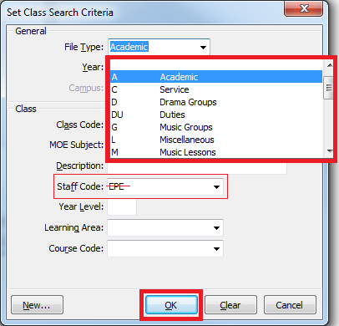

- In the Class Selector window. select the co-curricular class then,
In the Class Maintenance window on the right, click the Students tab
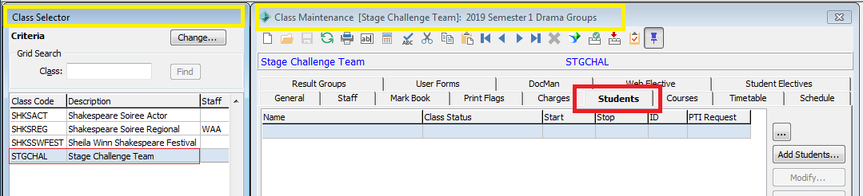

To Add a Student
With the Class Maintenance Window open
- On the Students tab, click Add Students...
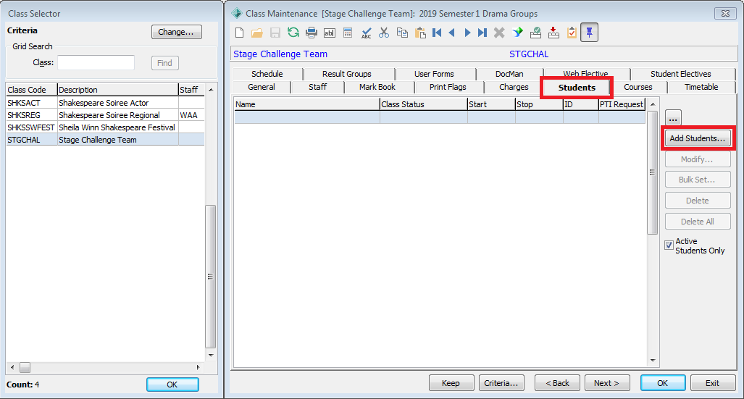

- Click Find...
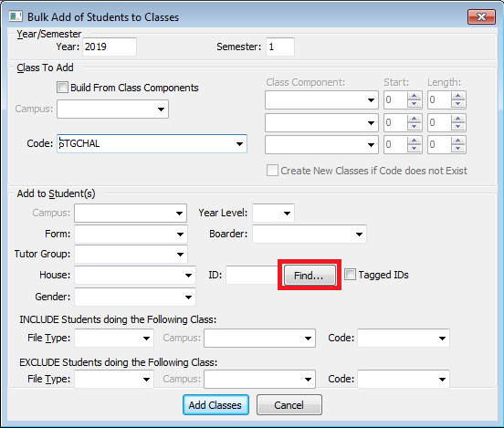

- Enter a few details such as the Student ID, Surname or Preferred Name then click Refresh Grid.
Select the student to be added and click OK
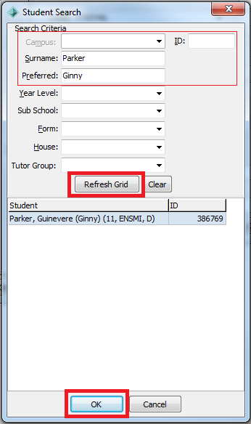

- Click Add Classes
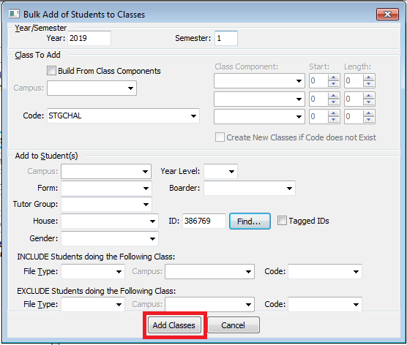

- Click Yes then OK
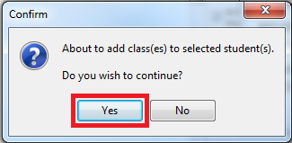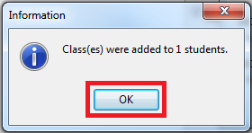

To add students from a Tag List
Multiple students can be added from a Tag List (ensure that the Tag List has already been created before continuing with the following).

With the Class Maintenance Window open
- On the Students tab, click Add Students...
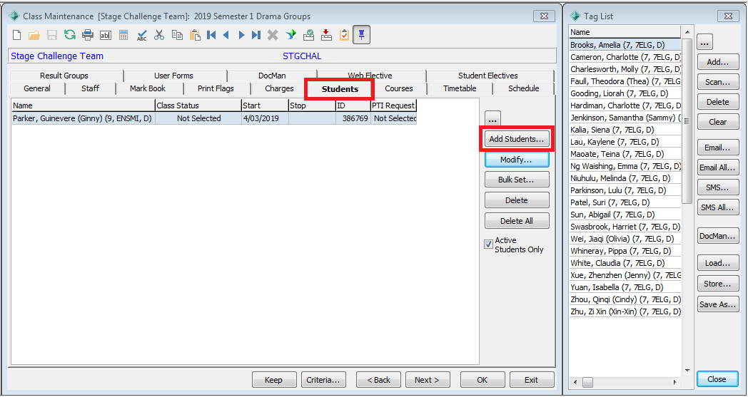

- Check the Tagged IDs option then click Add Classes
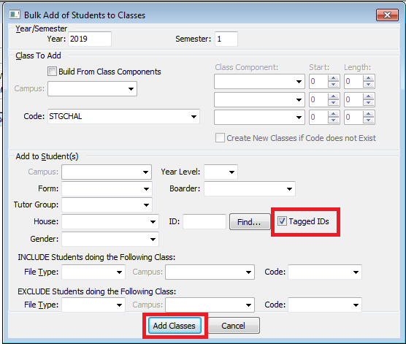

- Click Yes then OK
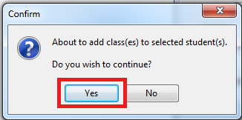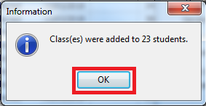

- Click Cancel to close the window that remains open or continue adding students
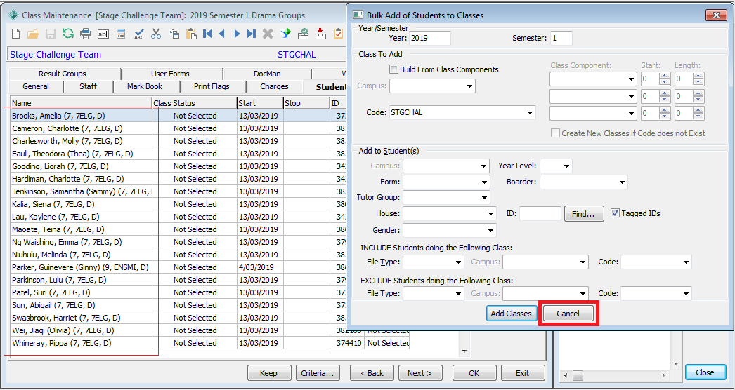

To Remove a Student
Note: when a student is finished in a class do not delete but rather, make them inactive by setting a Stop Date.

With the Class Maintenance Window open
- On the Students tab, select the student to be removed then Modify...
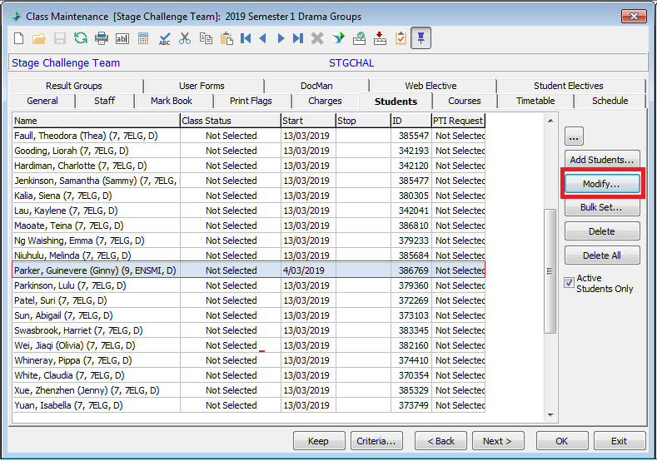

- Select a Stop Date, then click OK
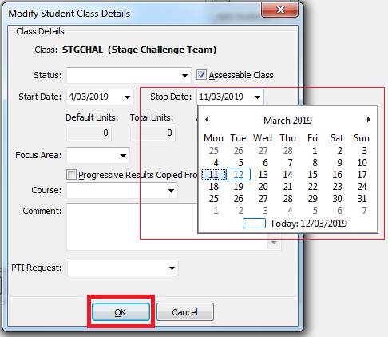

- To view students who are no longer active,
remove the check in the Active Students Only option
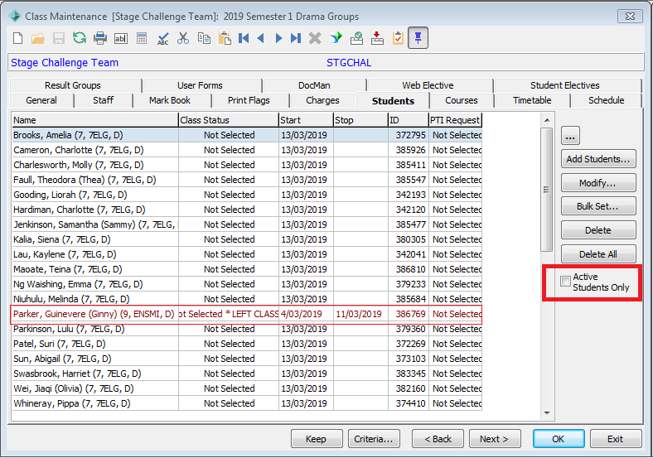

To Add a Teacher
With the Class Maintenance Window open
- On the Staff tab, click Add
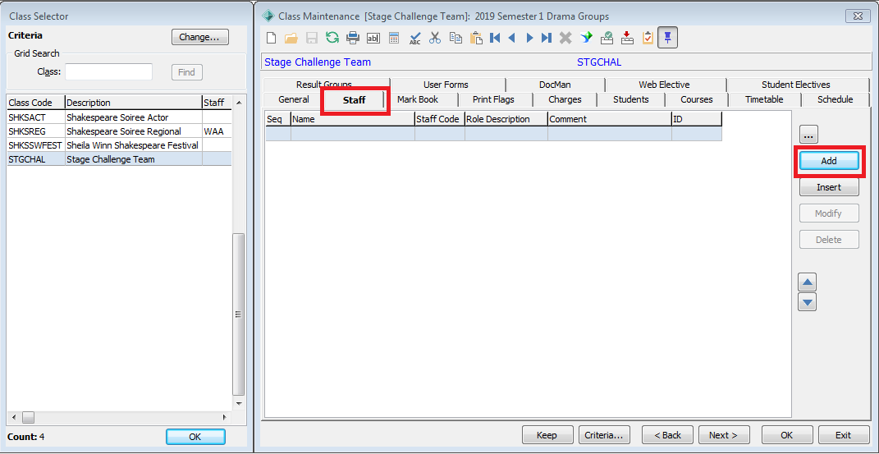

- The Staff Search window will open. Enter a few details such as the Staff Code, Surname or Preferred Name then click Refresh Grid. If multiple results appear, select the student to be added and click OK
