sYNWEB

ATTENDANCE MAINTENANCE FOR MUSIC GROUP TEACHERS
Synweb is an online version of Synergetic accessible via the internet. Music Group teachers can use Synweb to mark Attendances for their class of students.

- Login to Synweb
  - Login via myCollege, or see b below
Click on the Synweb link in the top navigation bar in myCollege, Synweb will open in another web-browser window/tab
  - Login directly to https://synweb.stcuthberts.school.nz, with your college Username and Password
    - Note: the Username field may pre-fill with stcuthberts\ in front of your username, if it does, delete it
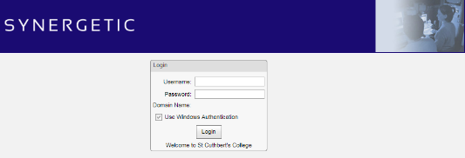
- On Login, the Timetable / Attendances for "todays" classes will appear under your name
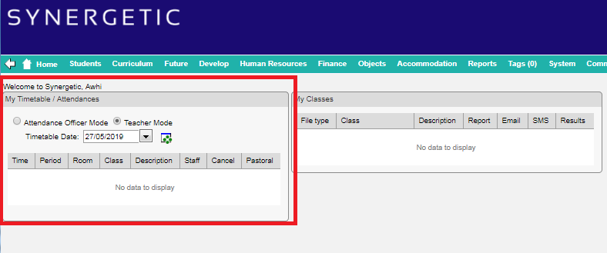
  - If you need to select a different date, click the down-arrow next to the Timetable Date field and click on your preferred date
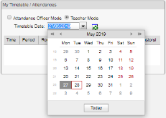

- Select the lesson, by clicking on the title in the Period column
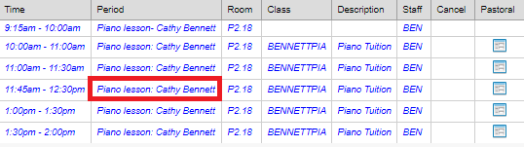
- Enter Attendance in the Attended checkbox/es then click Submit to save your changes
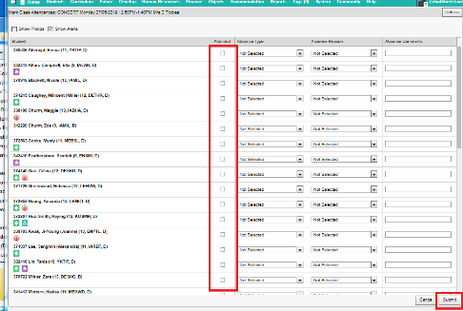
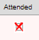 Did not Attend
Click once in the checkbox to add a Cross
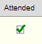 Attended
Click (slowly) twice in the checkbox to add a Check
NB: if you have incorrectly marked a student Attended; to change it to Did not Attend, slow-click on the Check mark (this will remove the Check Mark) then slow-click one more time to add the Cross.

